#### Creating & Editing Alerts

[Echoes - Land Management](https://echoes-platform.eu/app/main/map-view)

26 Steps

Go to <https://echoes-platform.eu/>

1 - (Option 1/2) Navigating to the 'Create Alerts' in site details (1/2)

Find the site you want to create and click into the sites details using the Ellipses and the 'Details' option.

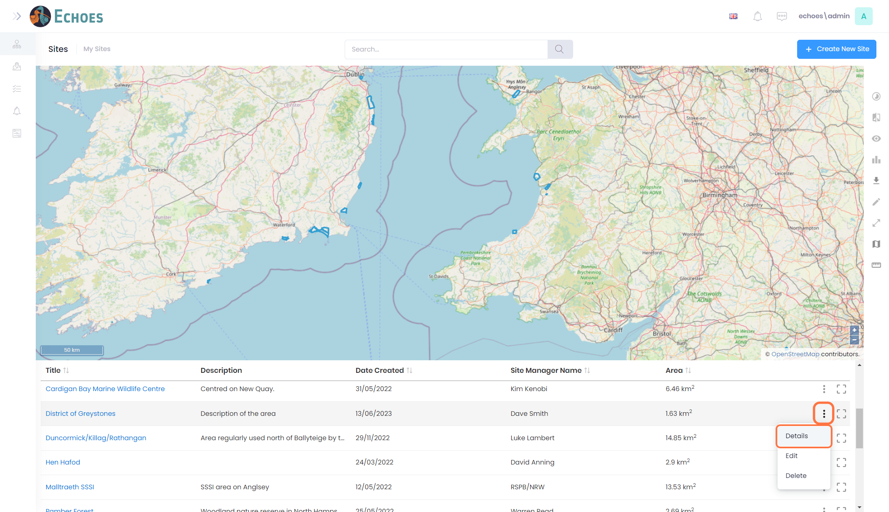

2 - (Option 1/2) Navigating to the 'Create Alerts' in site details (2/2)

Click on the Actions button then 'Create Alert' option

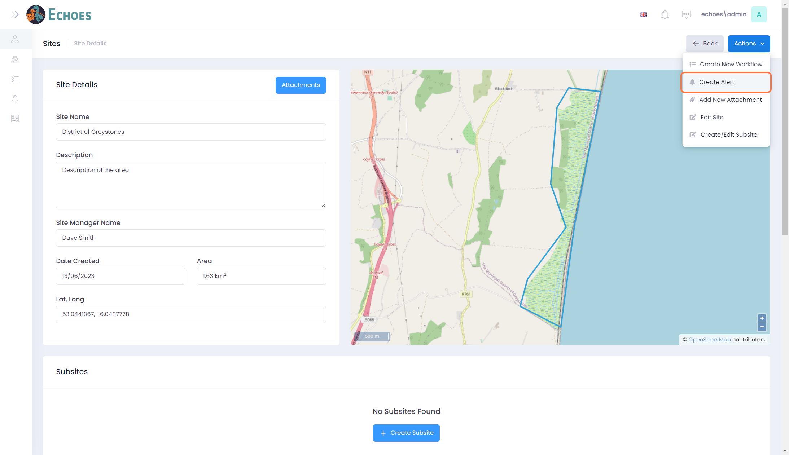

3 - (Option 2/2) Creating an Alert from My Sites

On the My Sites page, click find the site you want to create and alert for and click within its boundary, this will display a pop up similar to below. You can then click the 'Actions' button and choose the 'Create Alert' option from the dropdown

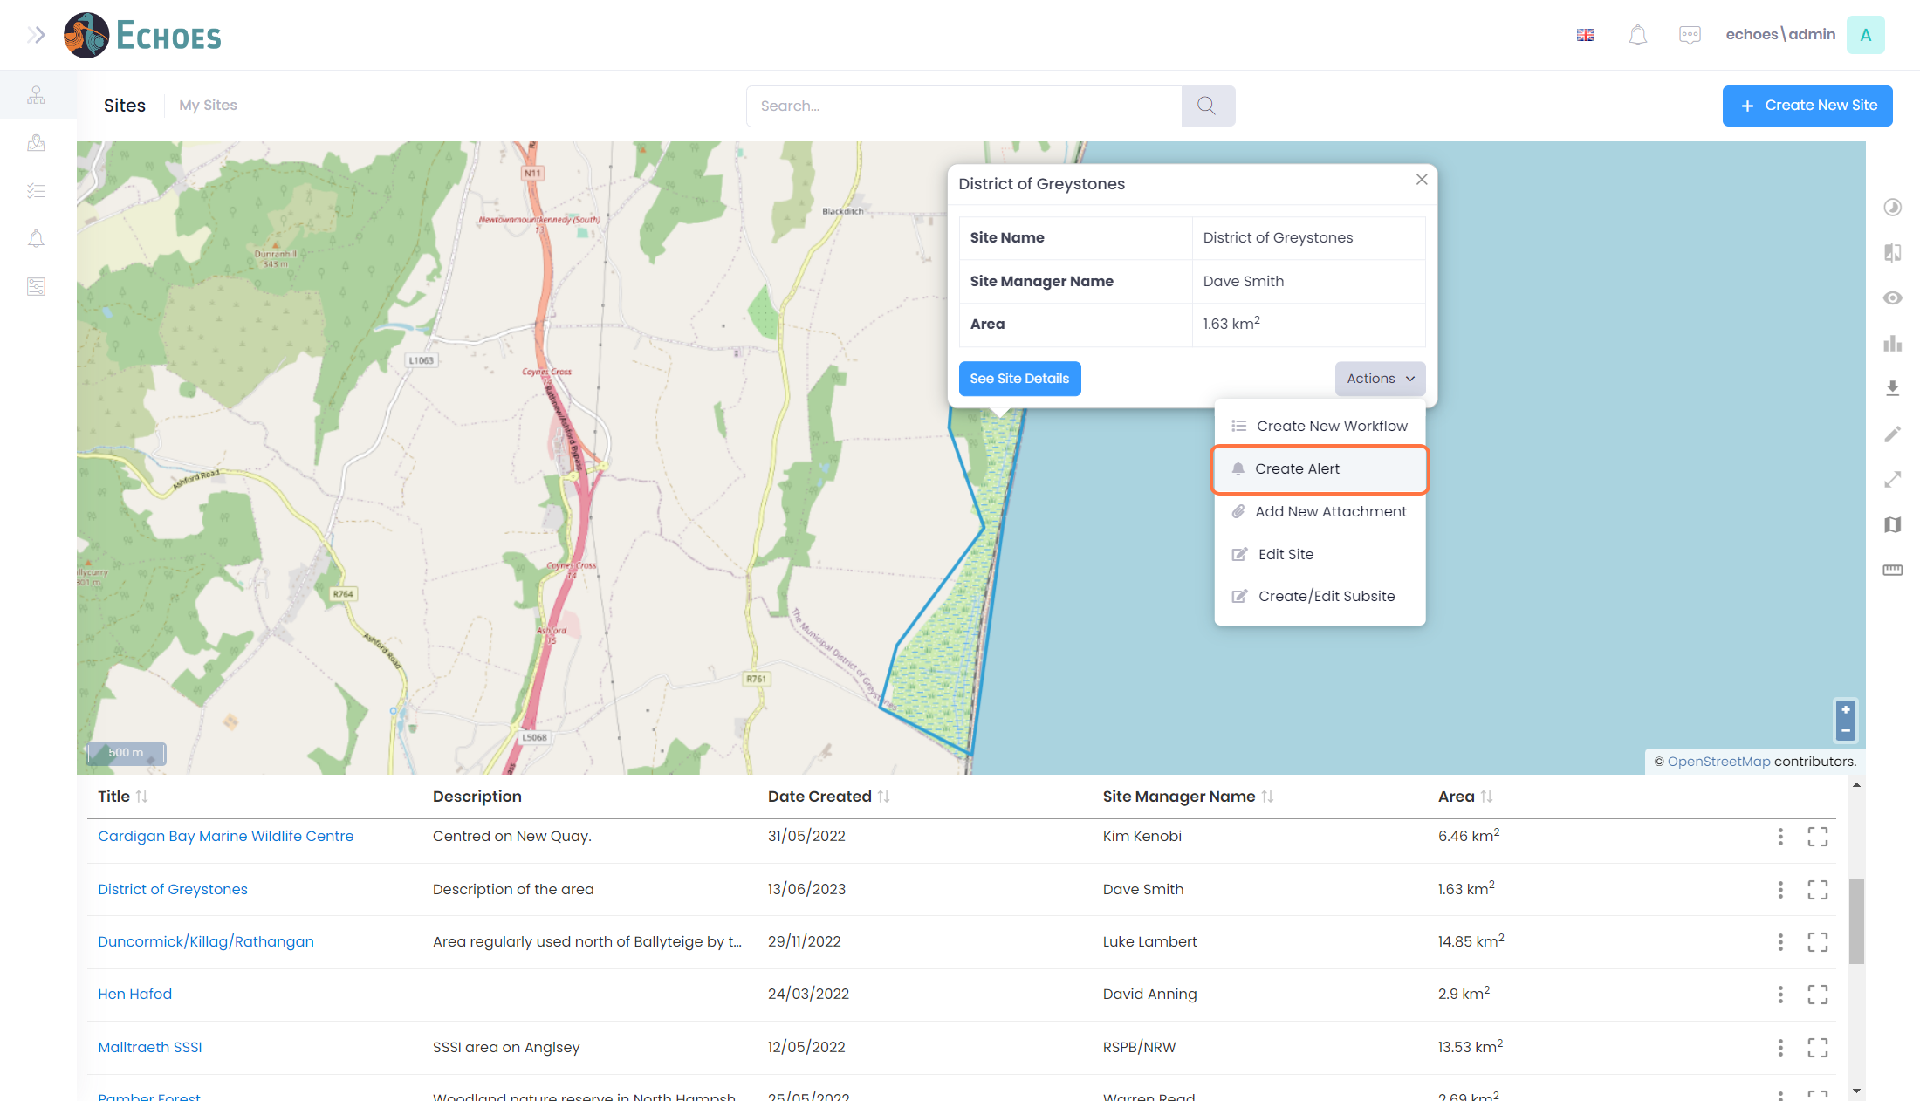

4 - The Create Alerts form.

Using either of the above options will take you to this same 'Create Alert' form

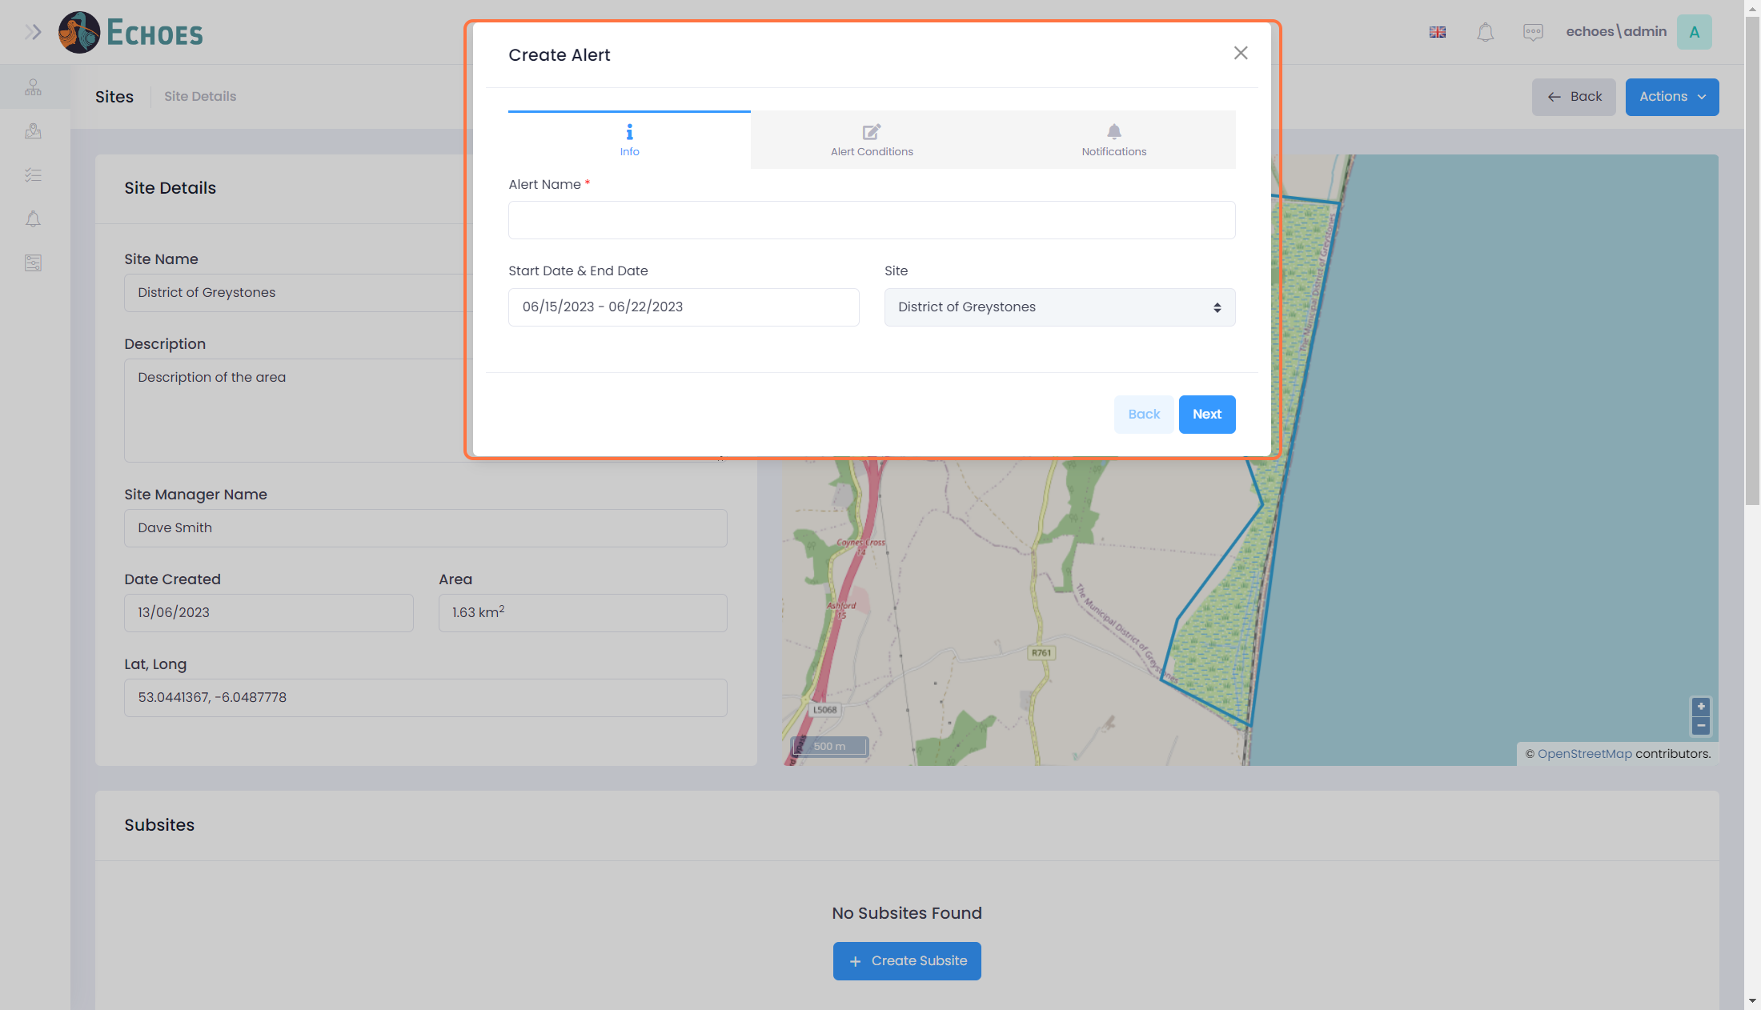

5 - Start the Alert form

To begin the form, give the Alert a name. This will be visible in the data table later.

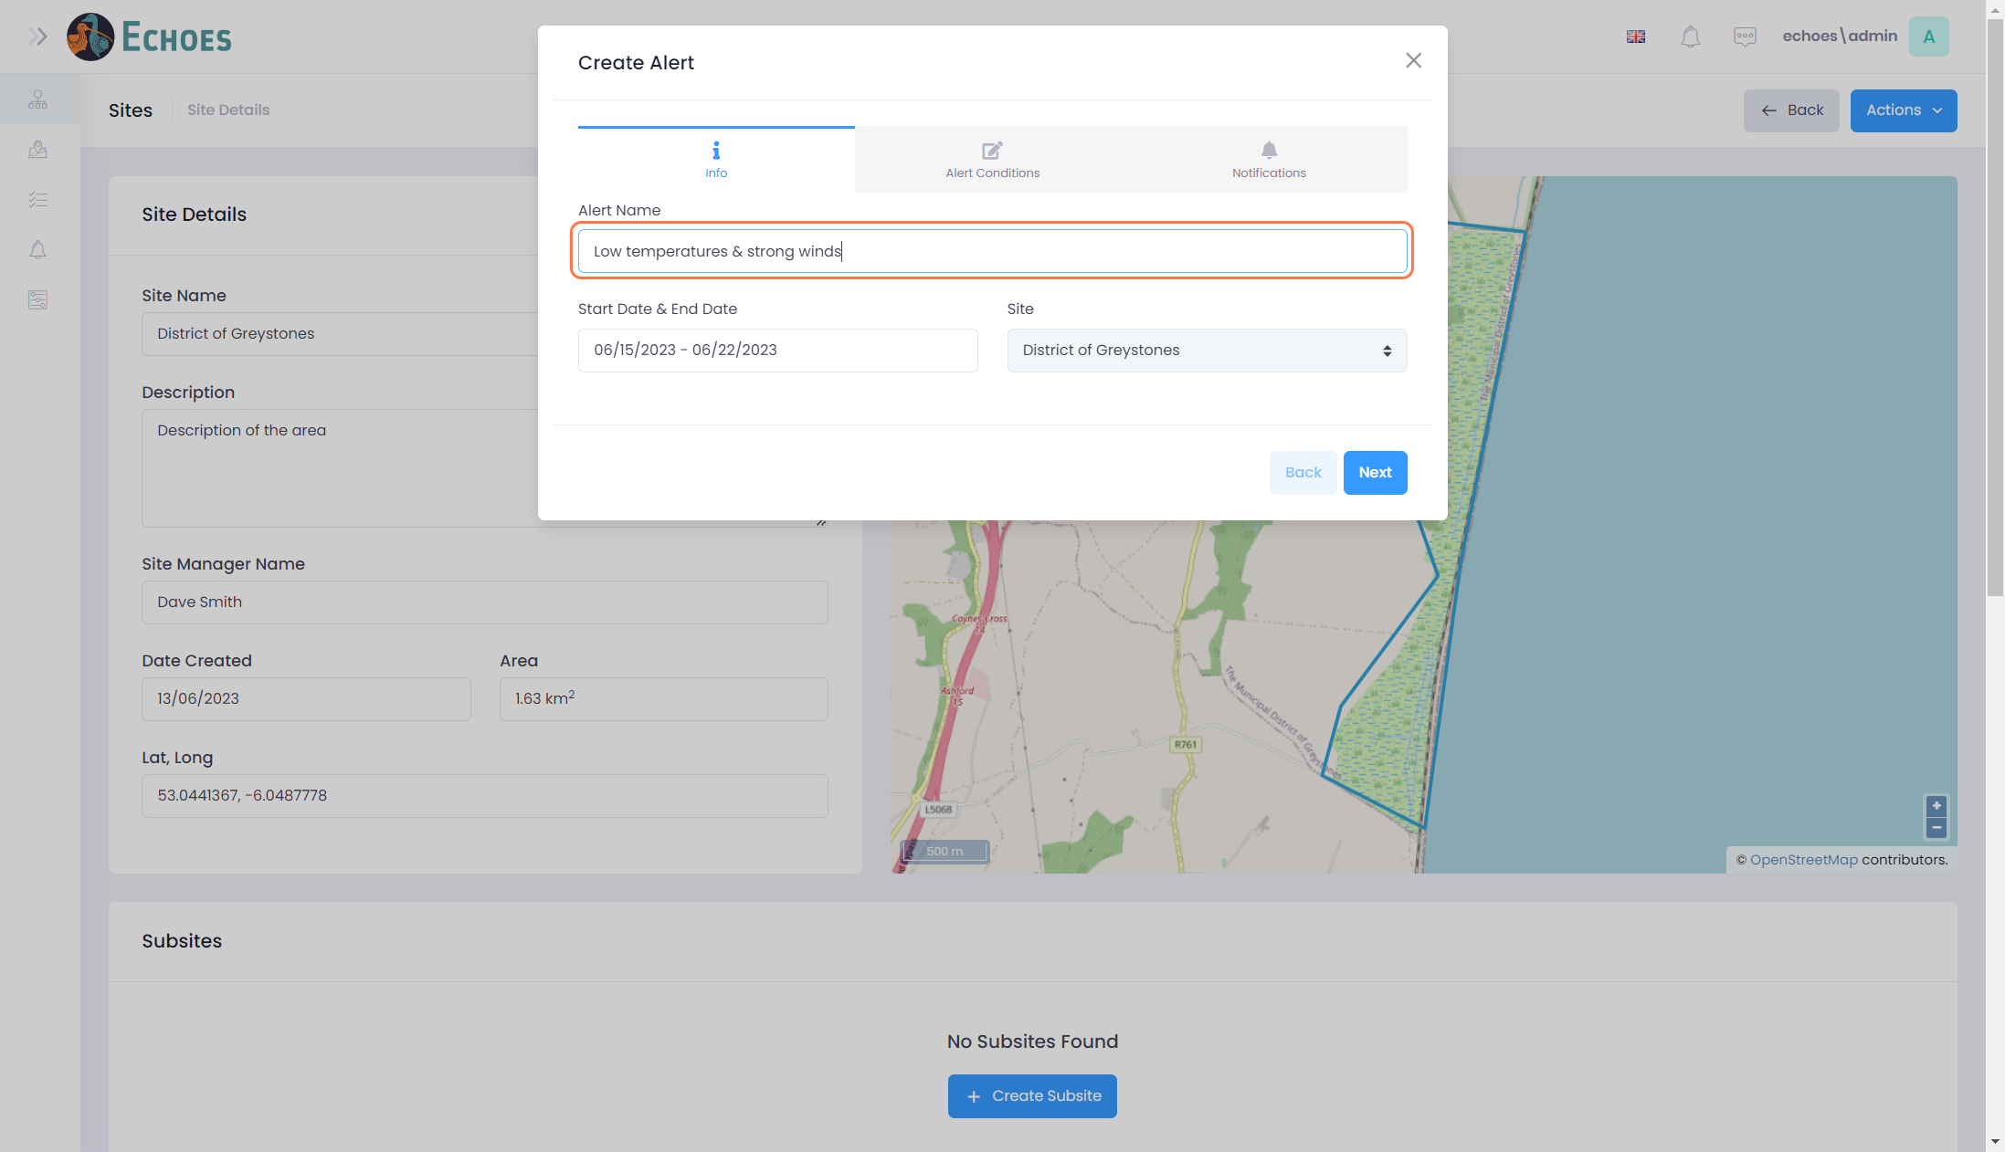

6 - Select a Start & End date

Choose a Start Date & End Date by first clicking the start date, then clicking your end date. This can be edited later if needed.

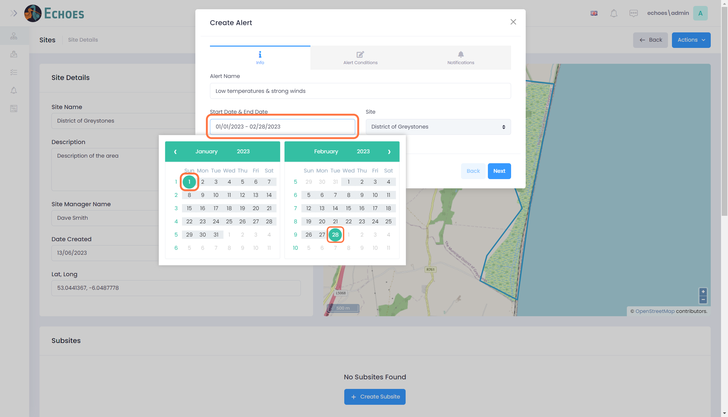

7 - Navigate to Alert Conditions

Click on either the 'Next' button in the bottom right, or the 'Alert Conditions' tab at the top to continue to the next step in the form.

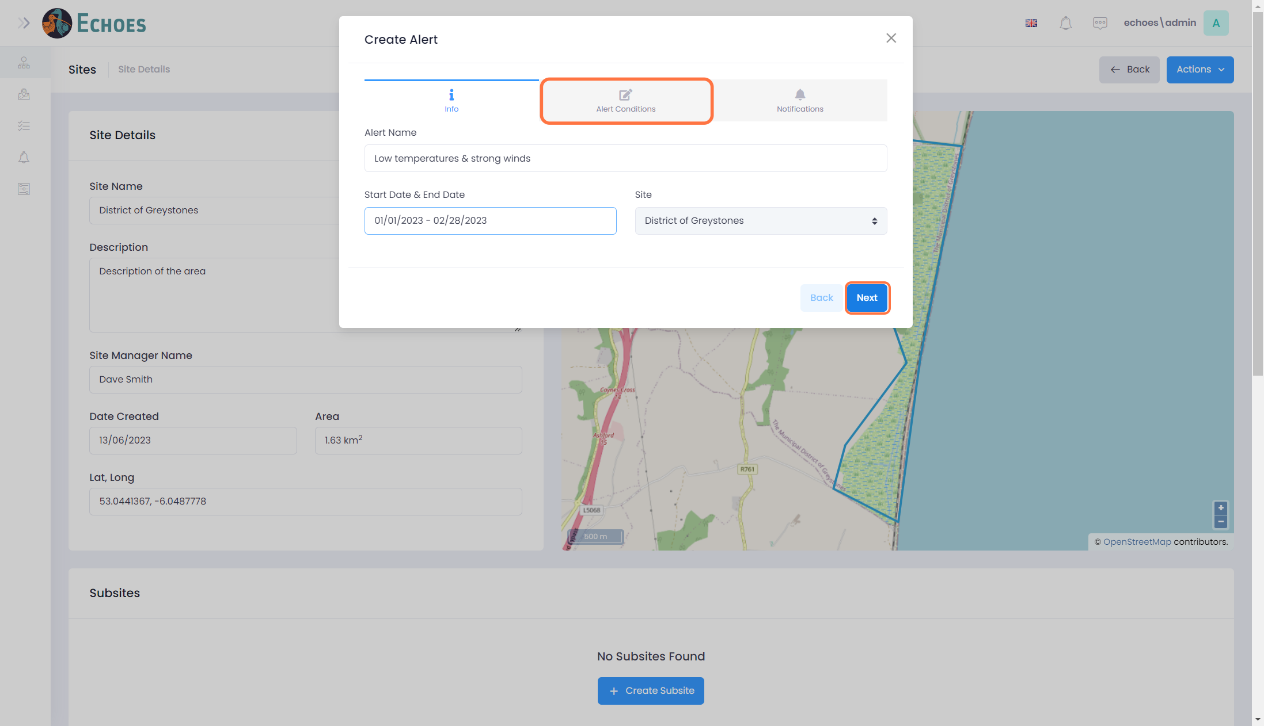

8 - Choose a Match Condition

Choose from 1 of the 2 conditions from the drop down:

* **All** - Meaning that if you have more than 1 condition in the alert, they all must be true for an alert to be triggered.
* **Any** - Meaning that if you have more than 1 condition in the alert, that only 1 must be true from an alert to be triggered.

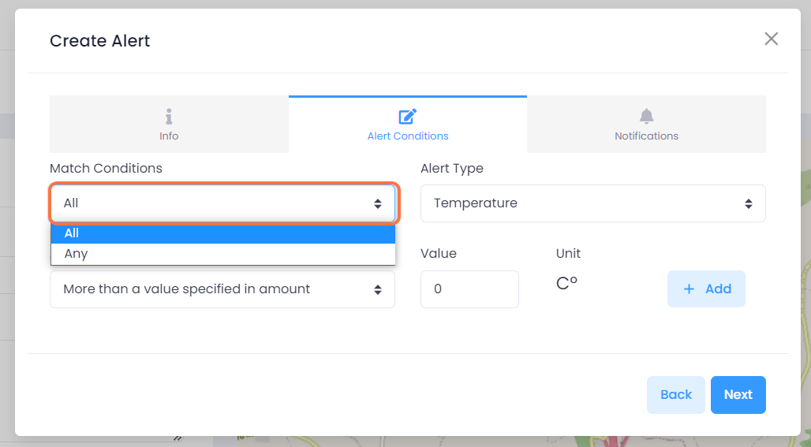

9 - Choose an Alert type

Choose from the drop down list an alert type from the drop down you would like to use.

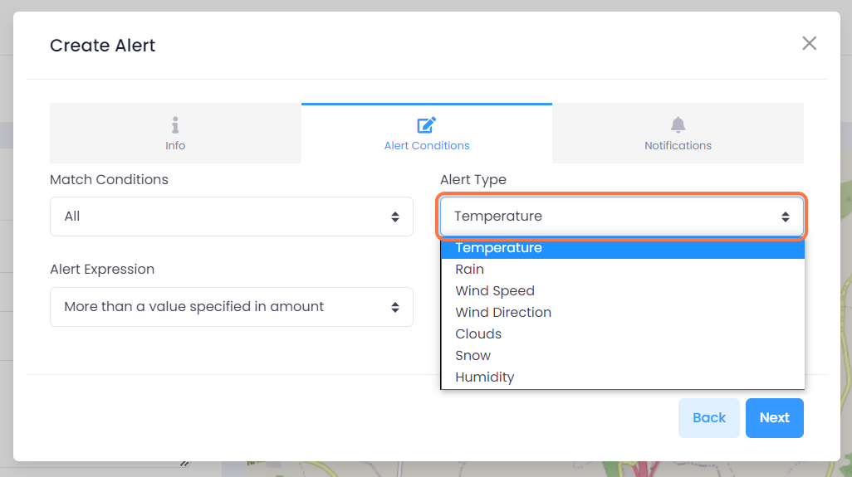

10 - Choose an Alert Expression

Select one of the parameters for the alert from the Alert Expression drop down

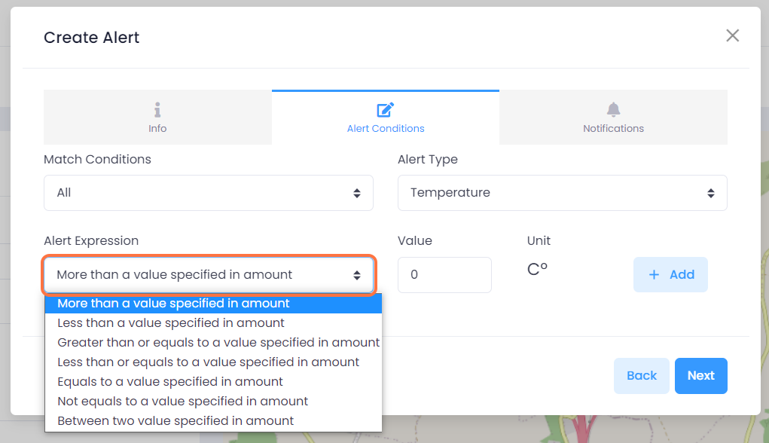

11 - Giving the parameter a value

Enter an Alert Value. You can see the unit of measurement next to the value.

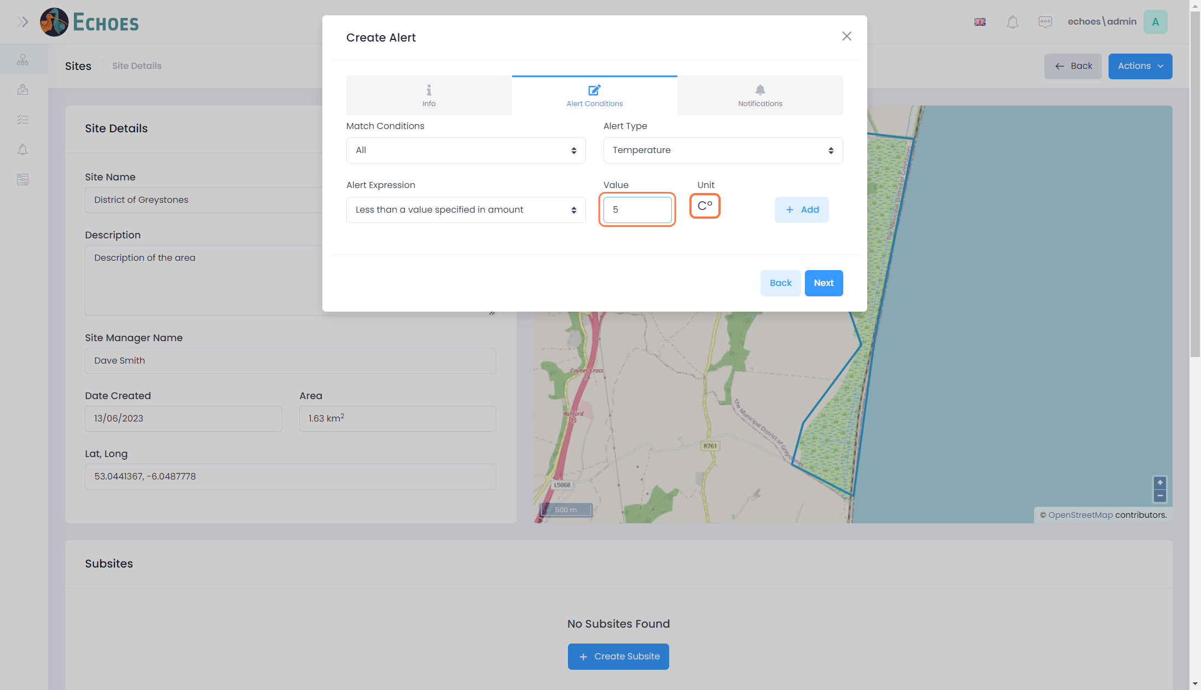

12 - Adding the configured Alert

Once you are happy with the conditions and parameters you have set for this condition, click the 'Add' button.

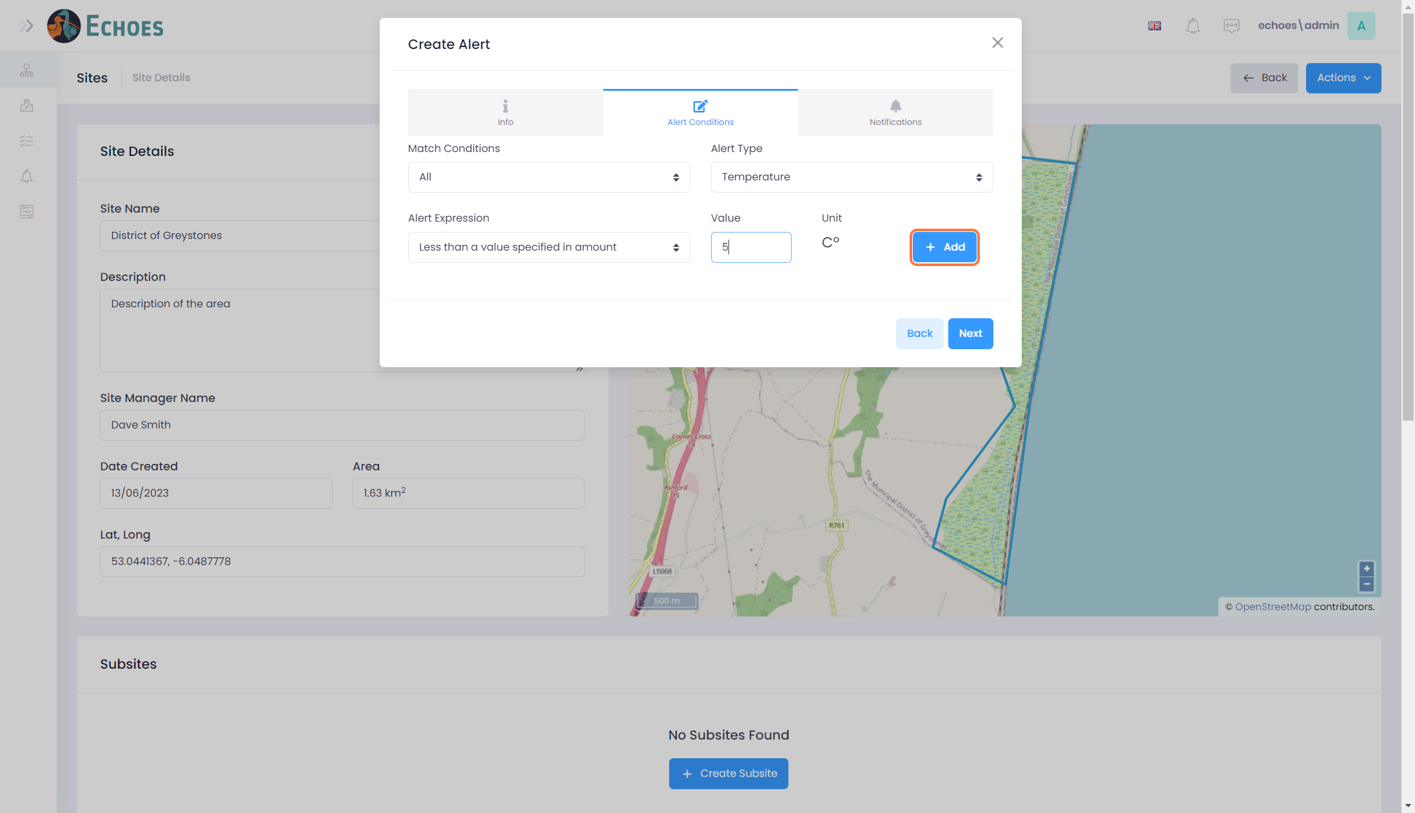

13 - Alert condition has been added

You will now see that the configuration you just created is now in the table, similar to below.

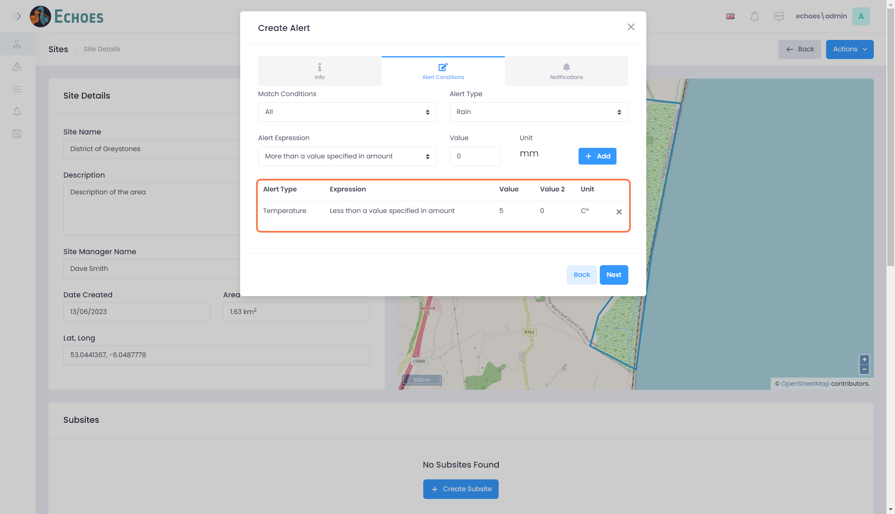

14 - Adding more than 1 condition to an Alert

You can combine conditions together if you wish, just follow steps 5-13 again with a different alert type and parameters.

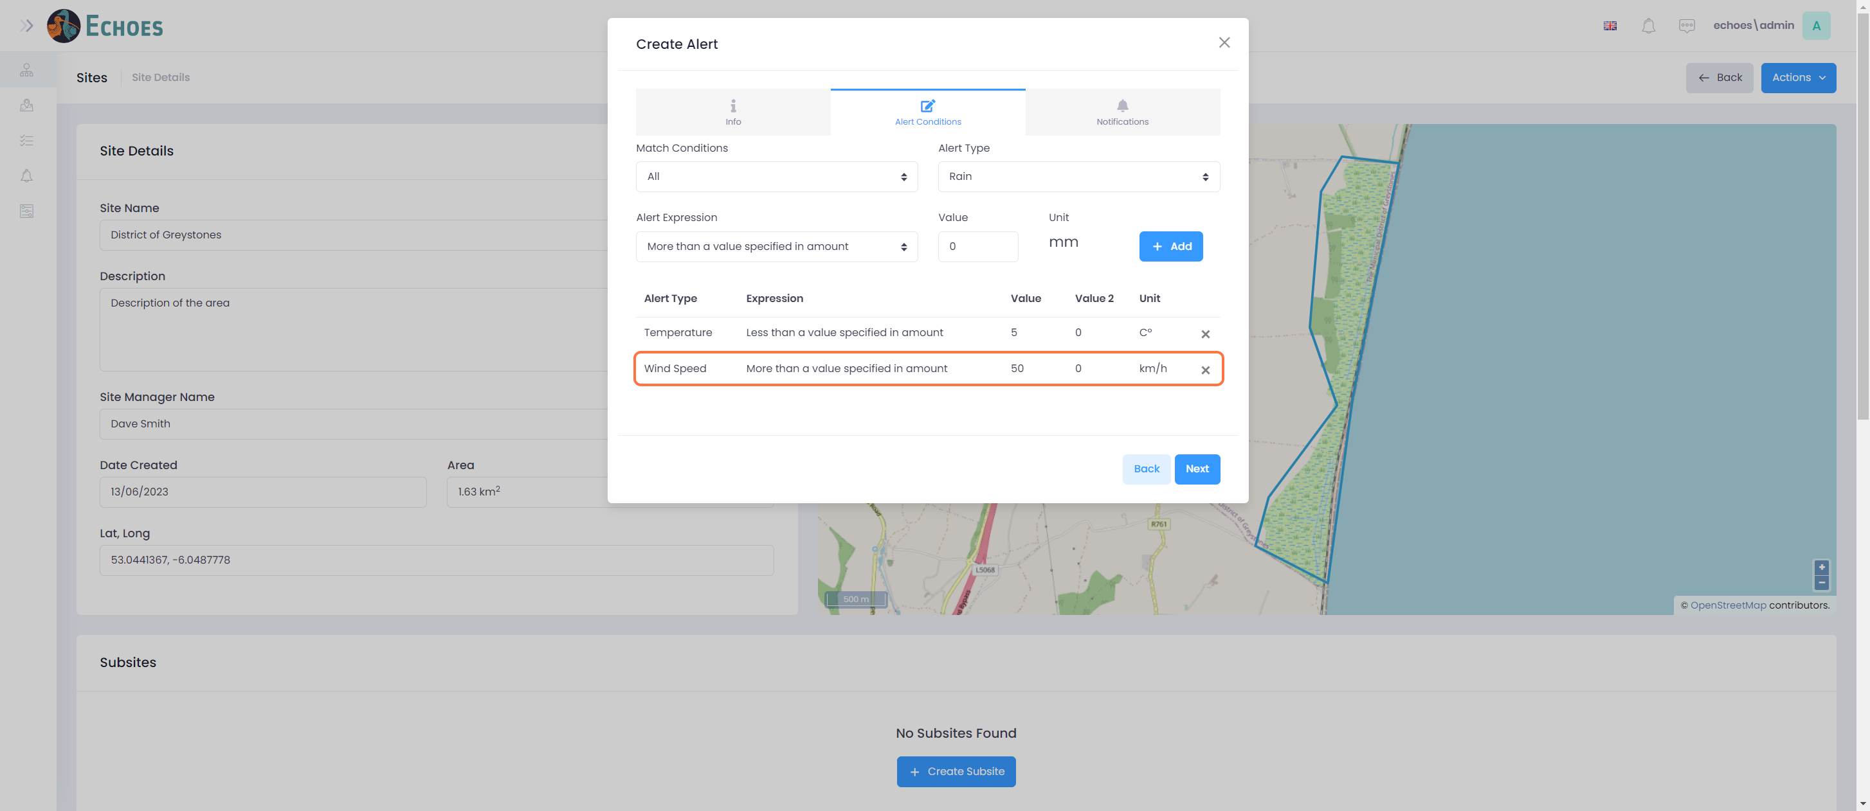

15 - Navigate to Notifications

Click on either the 'Next' button in the bottom right, or the 'Notifications' tab at the top to continue to the next step in the form.

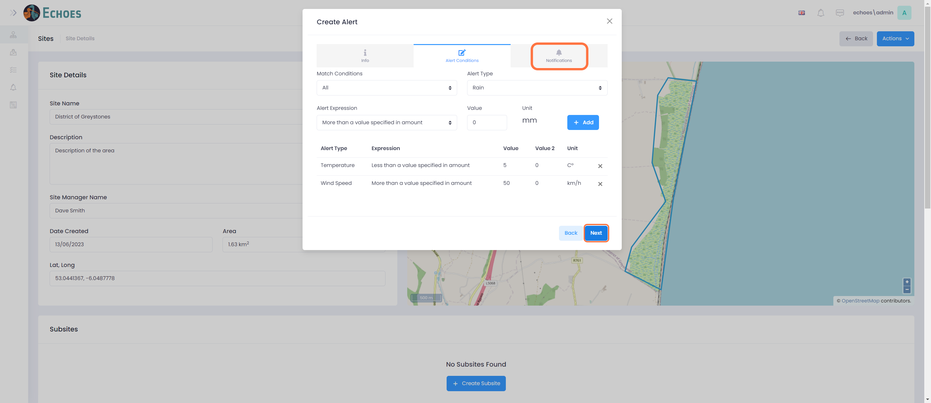

16 - Select a Notified user

Select from the drop down a user that will be notified in the event this alert is triggered.

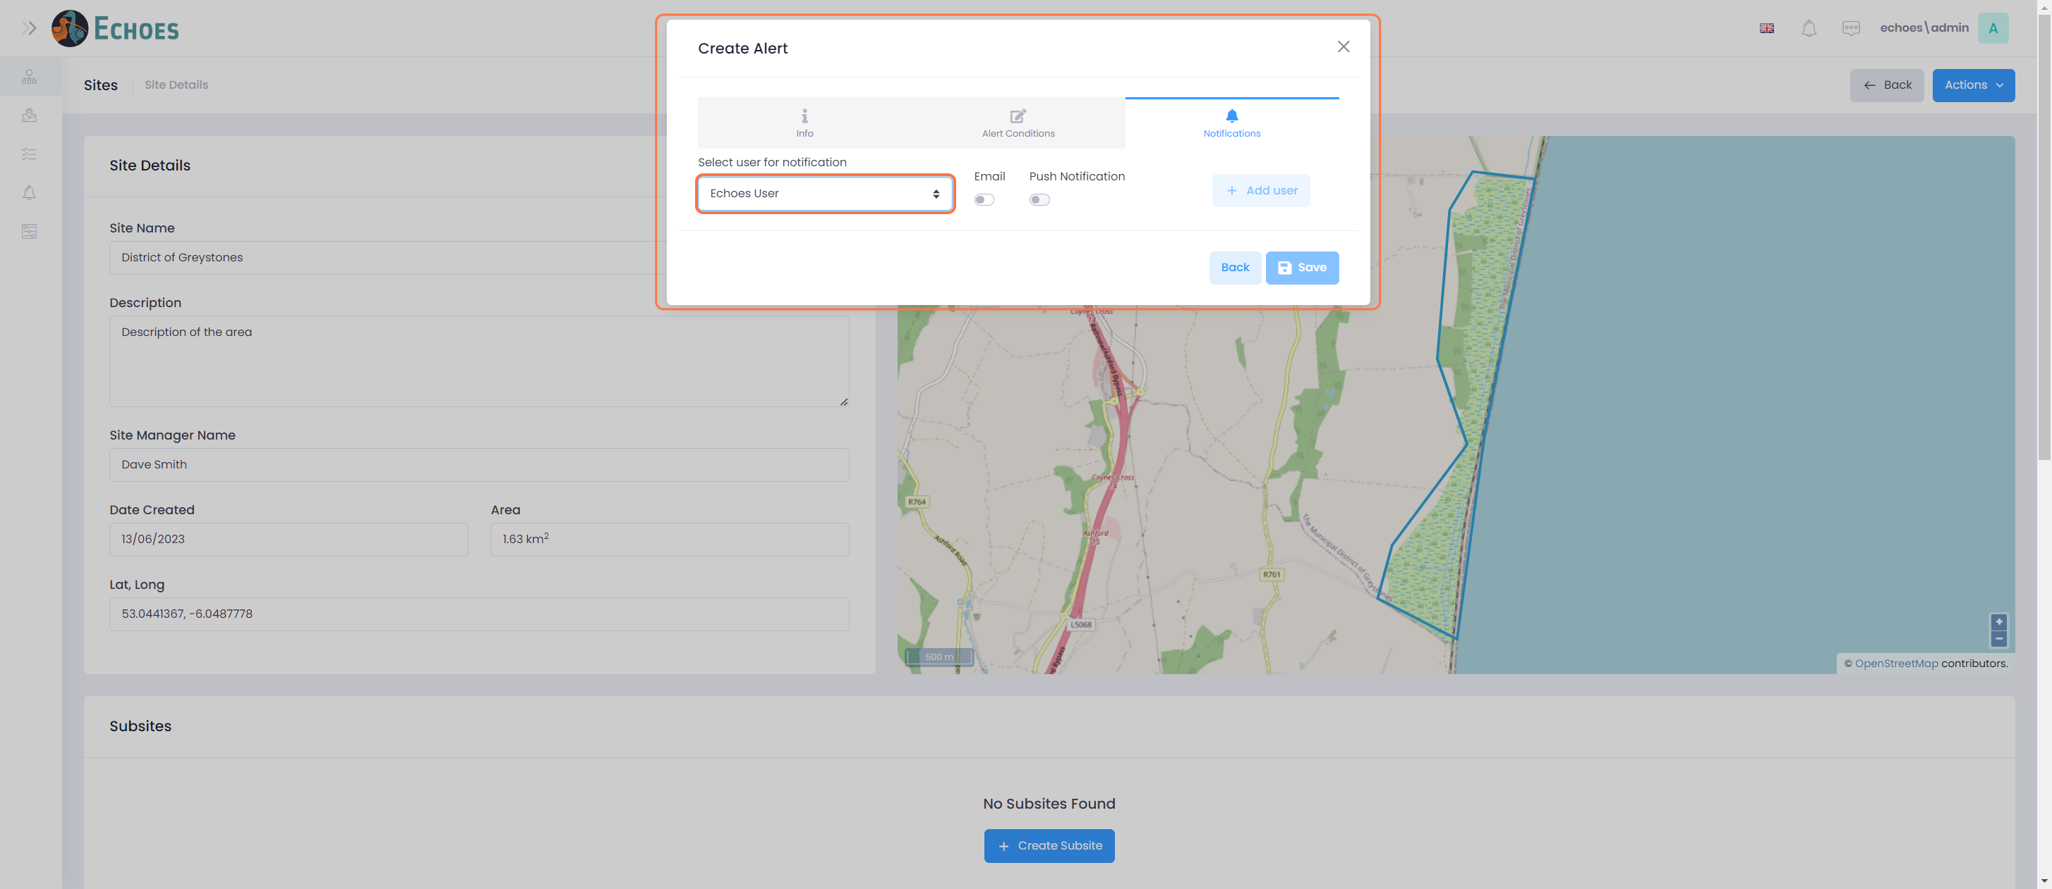

17 - Choose the notification type

Select the notification type. The recommended is the 'Email' option.

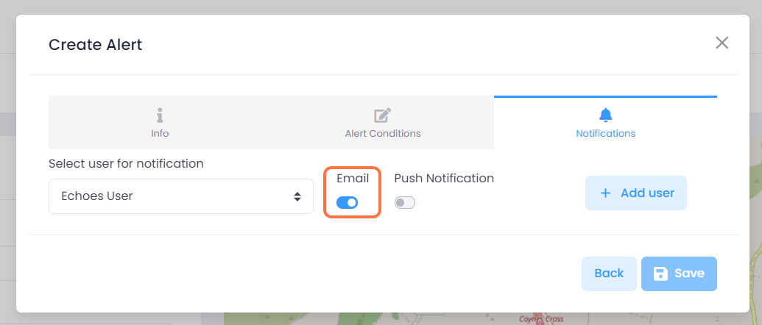

18 - Add the User

Once you have selected a user, click the 'Add user' button to add them to the alert notification list

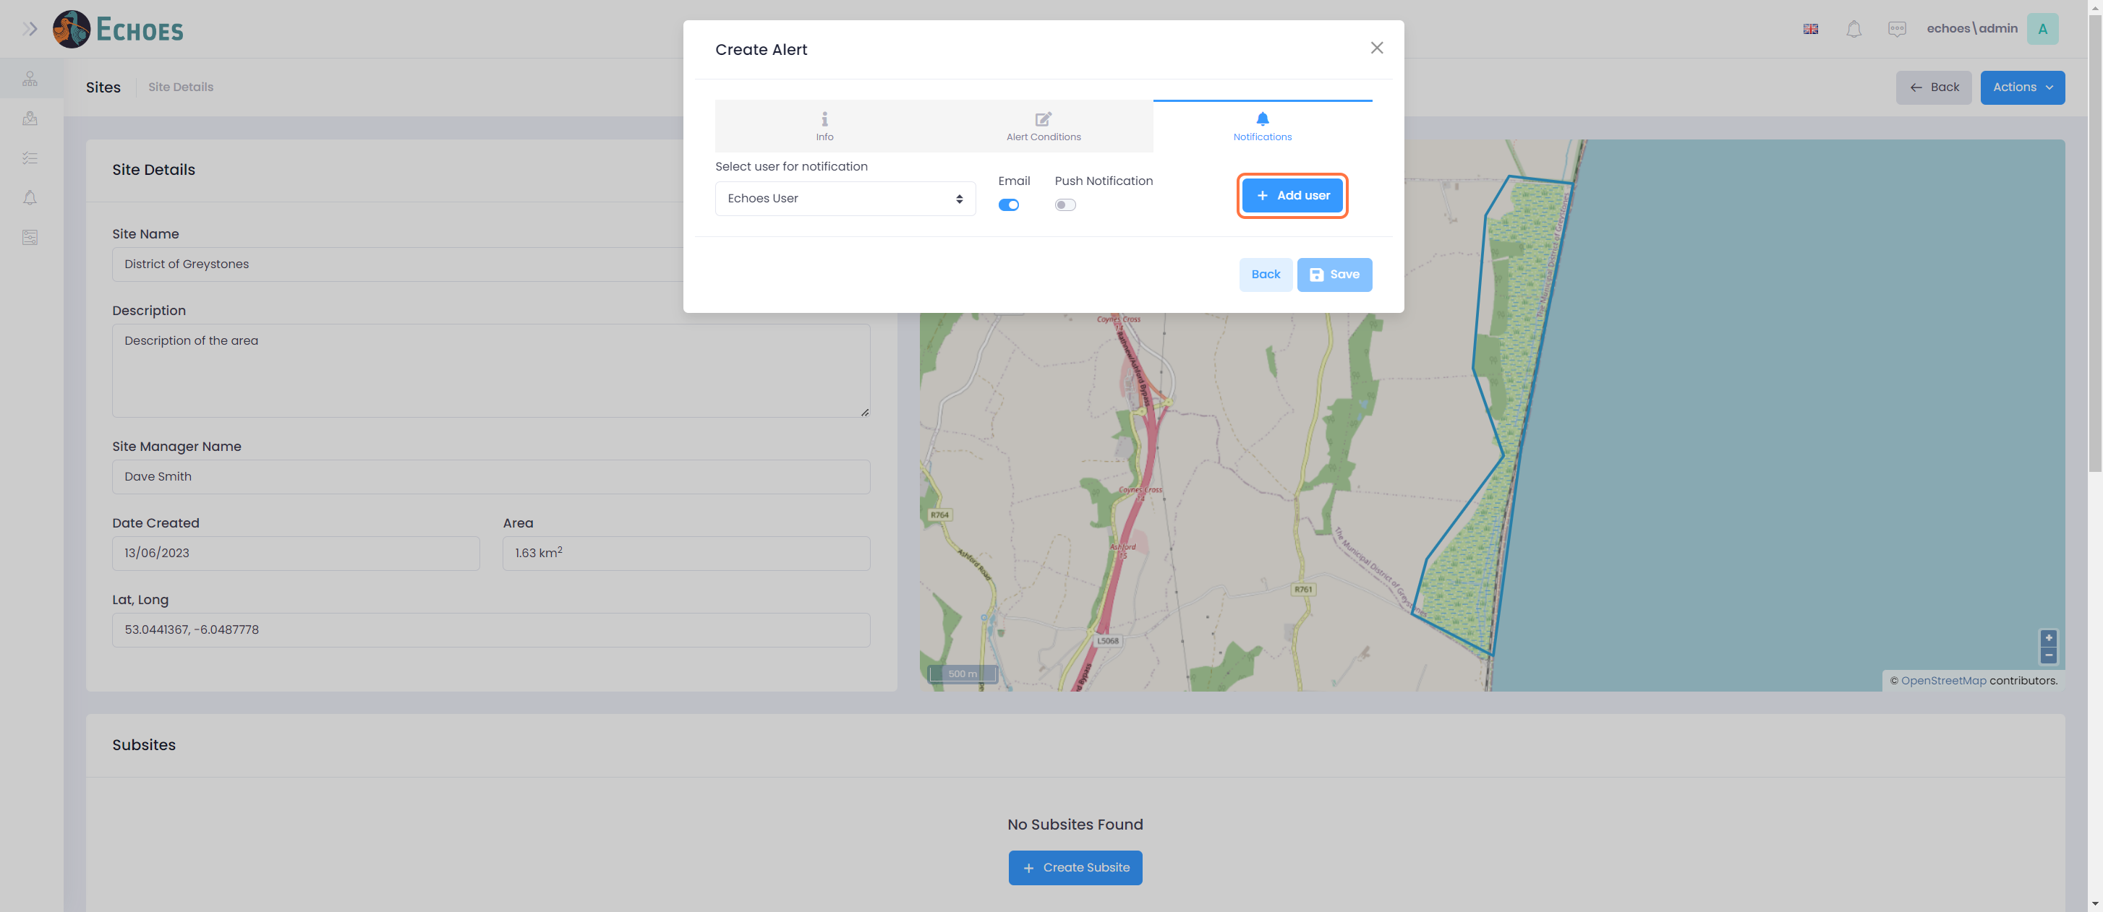

19 - List of notified Users

You can now see that the user you chose is added to the list. Complete steps 16-18 again to add more users to the list.

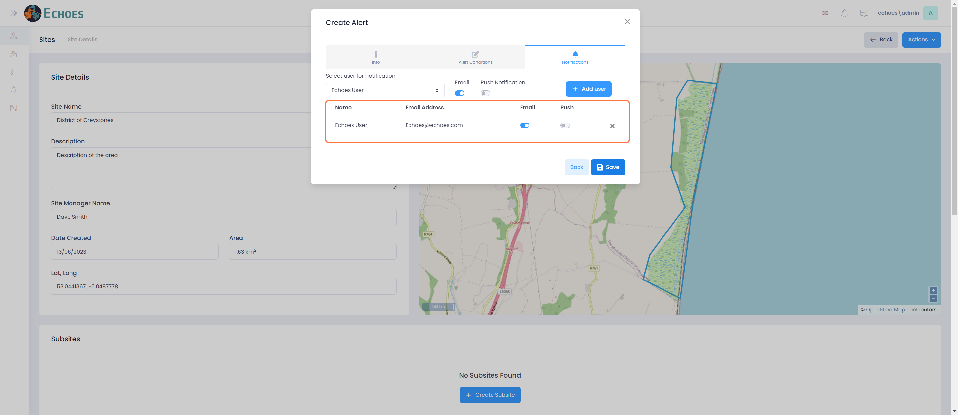

20 - Saving the Alert

Once you have filled out all areas and are happy, you can click the 'Save' button.

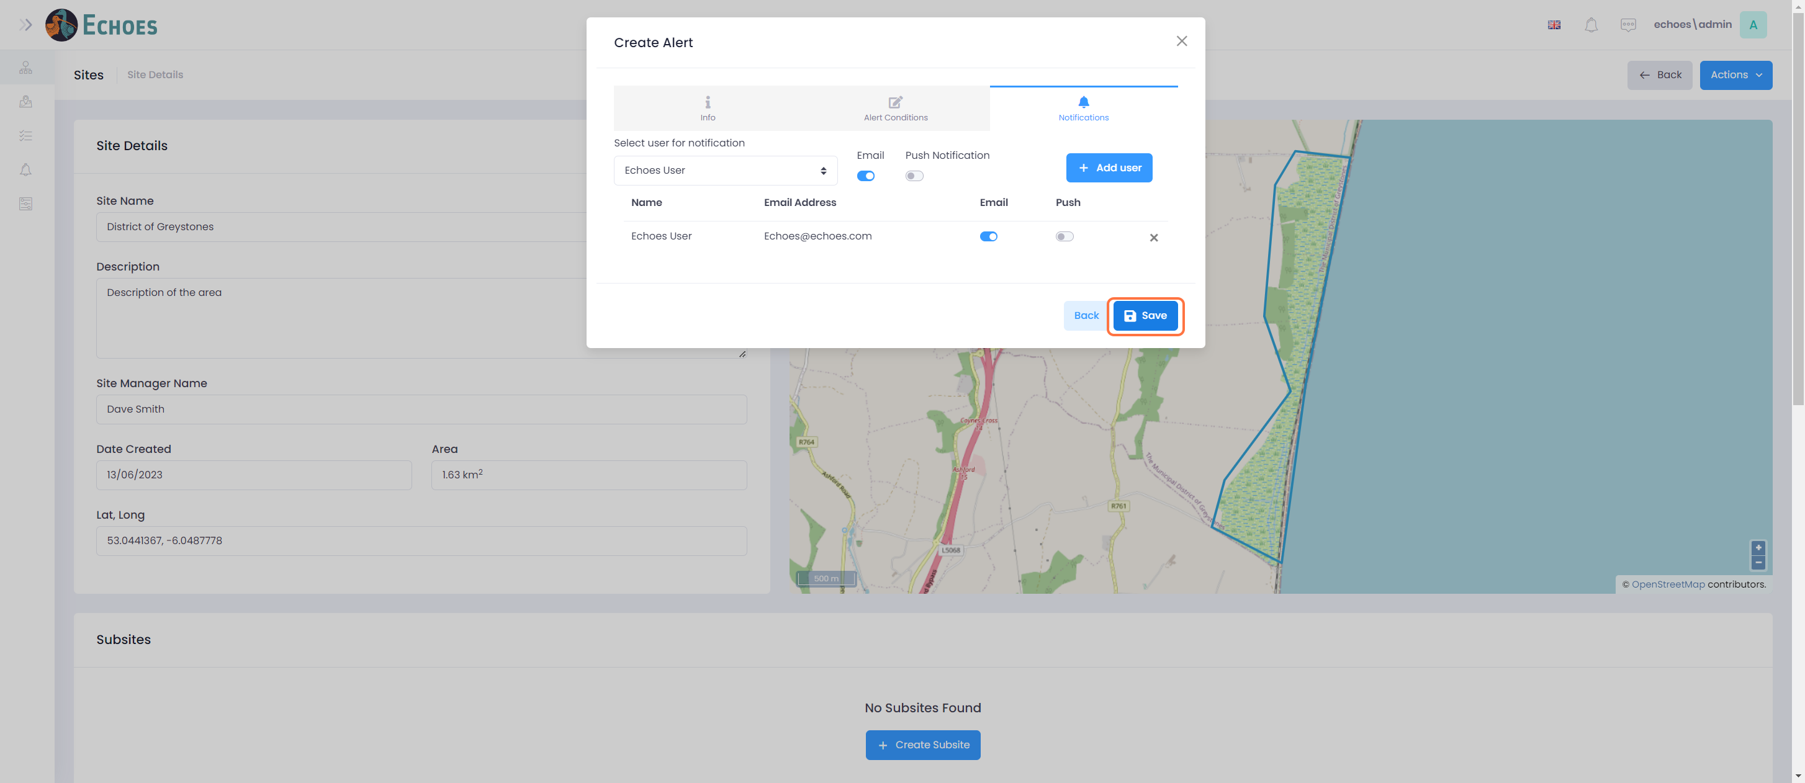

21 - Alert in the Data table (1/2)

Now you have saved the alert it is visible in the 'Alerts' section of the sites details page.

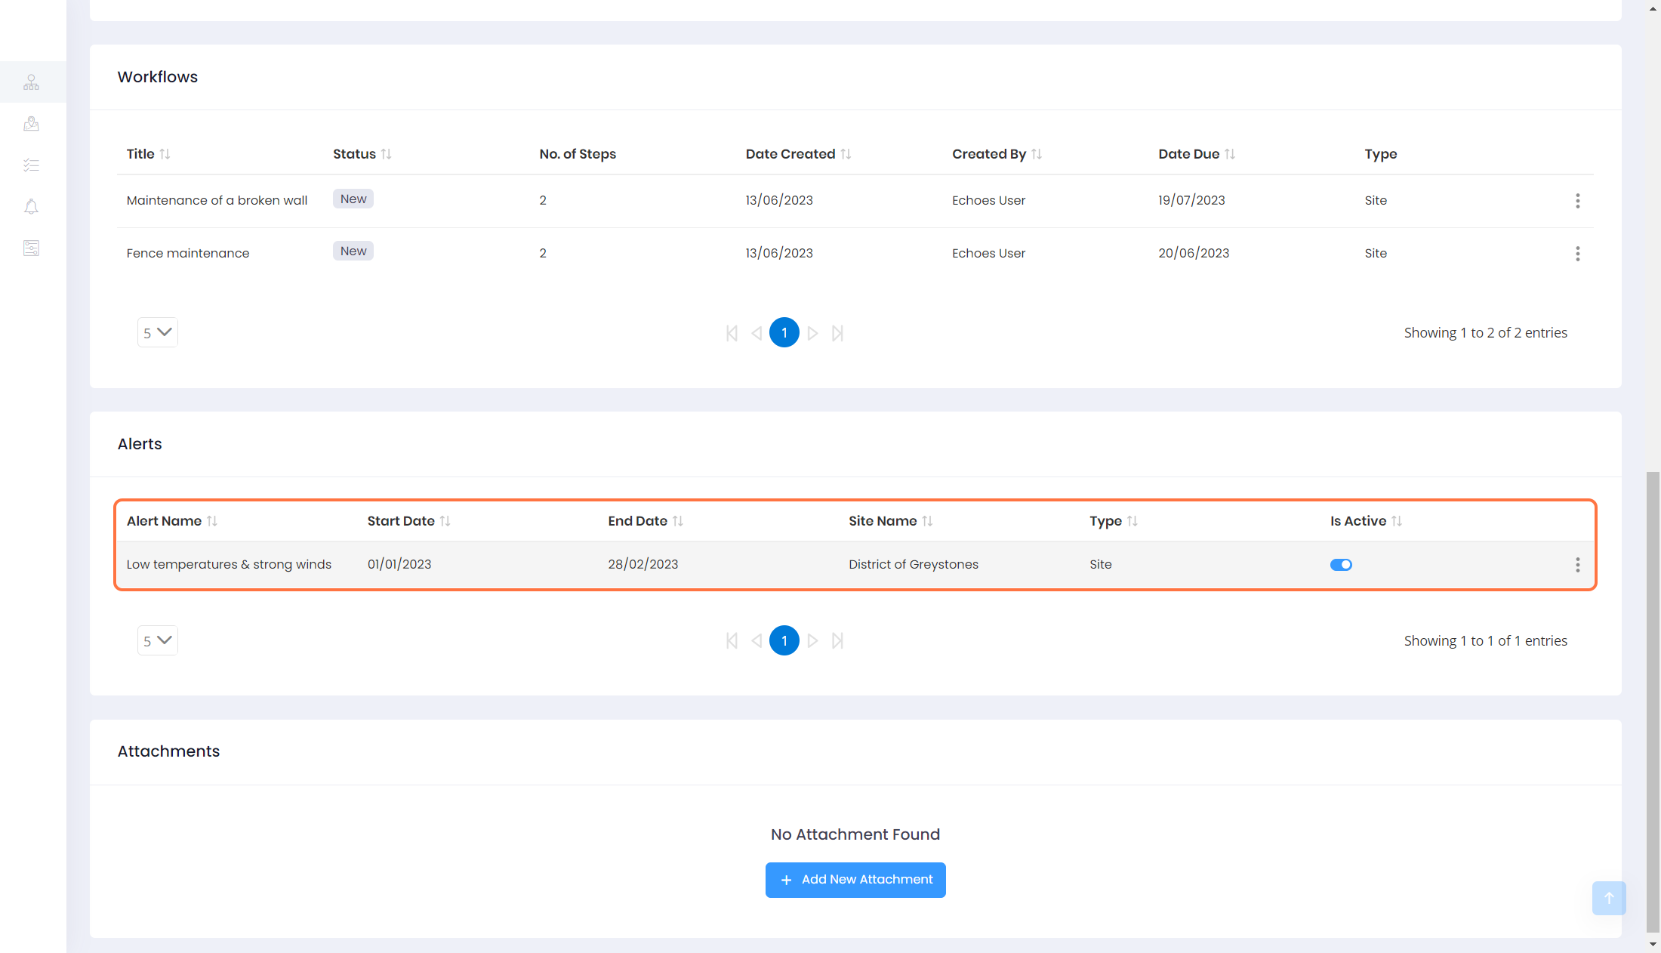

22 - Alert in the Data table (2/2)

This alert will also be visible in the 'Weather Alerts' tab where you can see all alerts for all sites in 1 place.

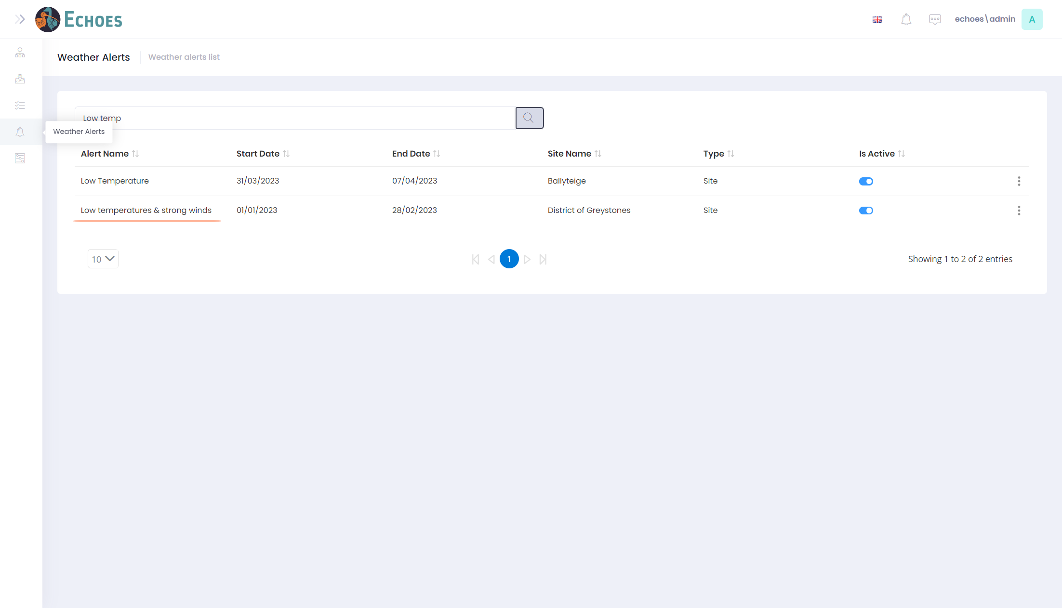

23 - Disabling an Alert

You have the option to disable or enable an alert by clicking the 'Is Action' toggle to either off to disable, or on to enable.

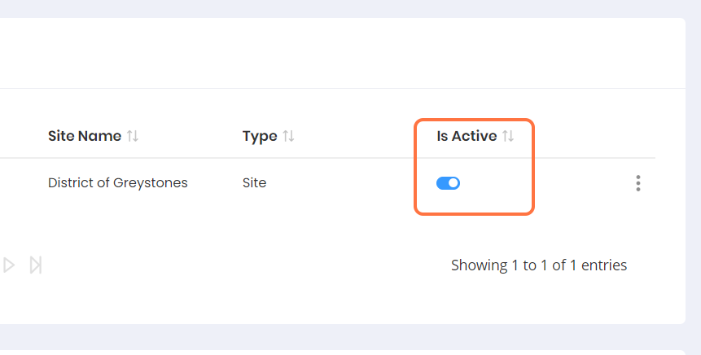

24 - Editing an Alert

You can edit any alert by clicking the ellipses icon beside it, then Edit.

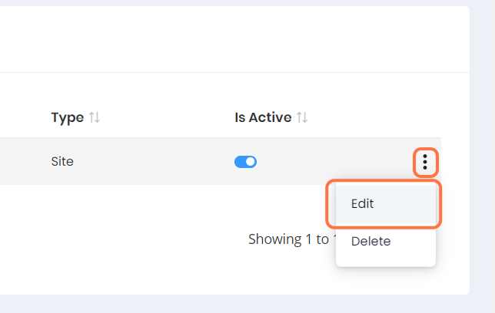

25 - Edit Alert form

This will open the Edit Alert form with all the same details as when it was created.

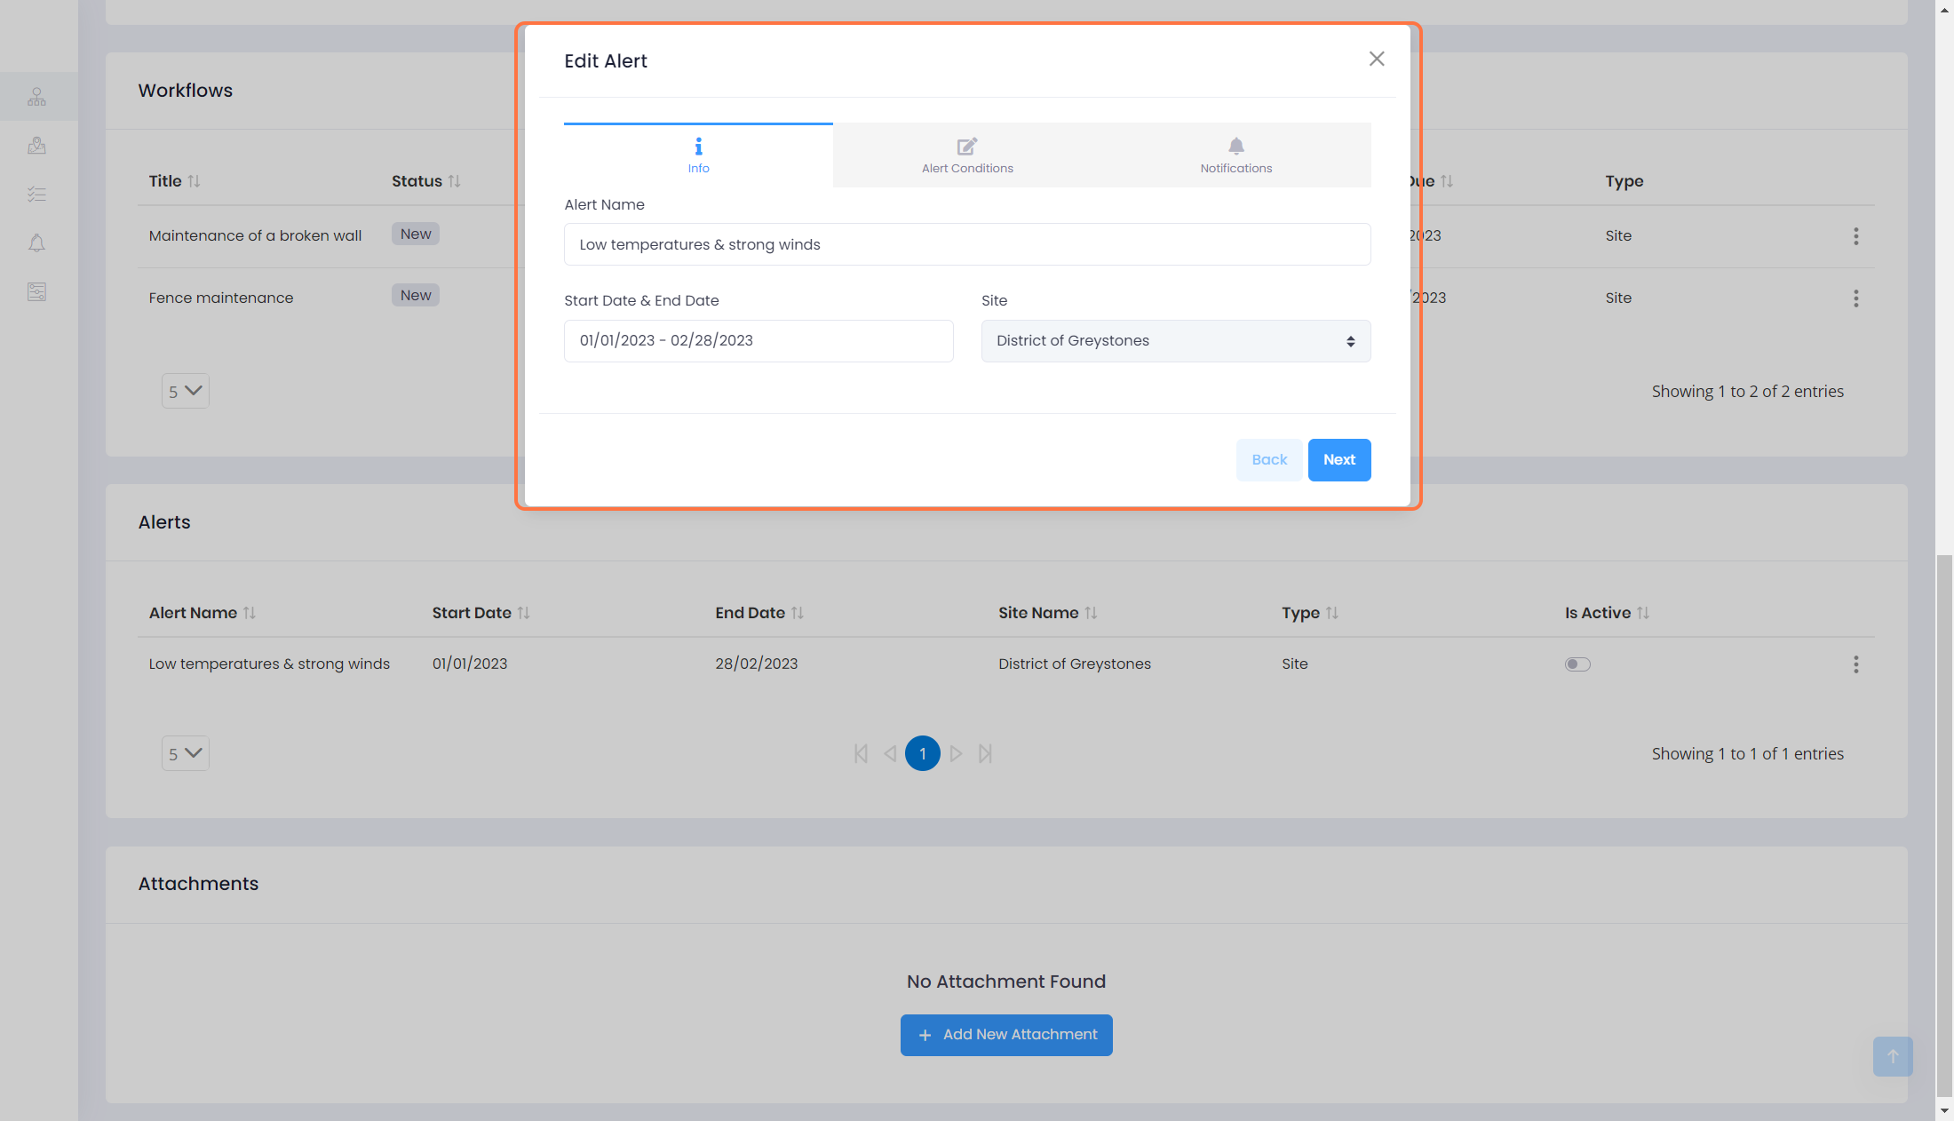

26 - Saving Edits to an Alert

Navigate to 'Notification' and 'Save' to save any edits

